**Homework Week #3**

(20 points total)

Using what you’ve learned so far in the course, specifically during week 3, answer the following questions.

Question 1. (2 points) What command can the current users execute to show a list of commands previously entered? Explain the utility of this command.

The history command allows the user to show the previous commands. The utility is that you are able to see your previous commands with ids for each of those commands.

Question 2. (4 points) Create a new environment variable named EVENT and set it to the value “now” by using a single command. Once complete, display all of the existing environment variables.

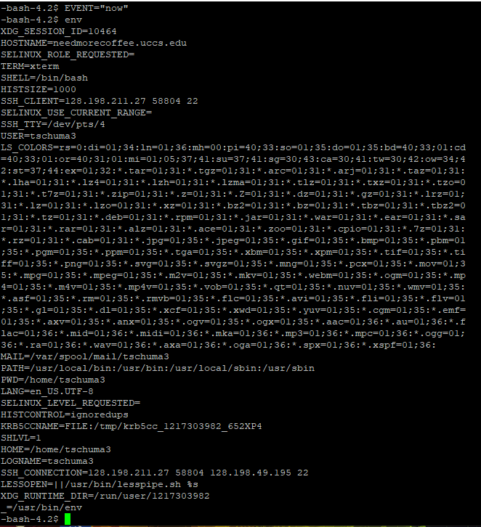

Question 3. (2 points) What are the results of using which for a command that is located a directory other than your current search path? 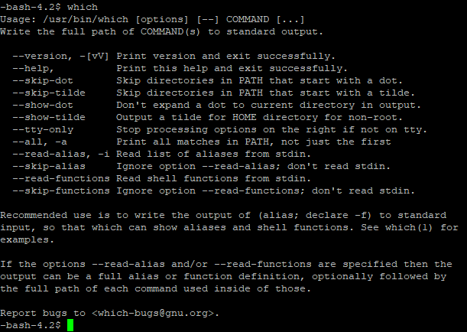

Question 4. (2 points)

1. What command displays current the aliases?

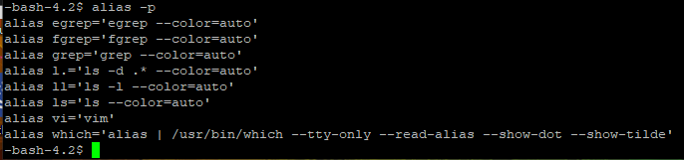

1. Write an alias command to list only the hidden files within the current user’s home directory.

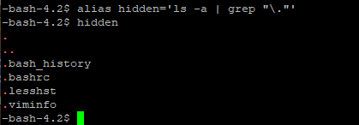

Question 5. (2 points) Explain the activity of the shell while a command is executing? How can you avoid waiting before running another command?

While the shell command is processing, the shell interprets the command, creates a child process, execute that child process, and waits for the child process to finish. You can avoid waiting by appending, “&”, to the command line to run in the background. You can also “control Z” to suspend the process.

Question 6. (3 points) Enter the following command: $ **sleep 30 | cat /etc/services**

Is there any output from sleep? Where does cat get its input from? What has to happen before the shell will display a prompt?

There is no output from sleep. Cat gets it’s input from /etc/service. The sleep command will have to run for the entirety of its duration.

Question 7. (3 points) Assume the **PATH** variable has been deleted, what are some of the problems that could arise? What is the reasons for these problems? What is the simplest way to restore **PATH** to its original state?

If PATH does not exist, then the shell won’t be able to find the exact location of any command that is entered. PATH is an environment variable which effects the way running processes happen on a computer. The easiest way to restore is to exit the program. You can also use the “export PATH=$PATH: ” command.

Question 8. (2 points) What can you do to make the function available every time you log in? (2 points)

You would need to write the alias to a file to save it or to the file that runs as soon as the session starts. This can be done using commands such as ~/ .bashrc or ~/ .bash**_**profile.